**FT_DS-G10 E-L-V2.0.2.231219**

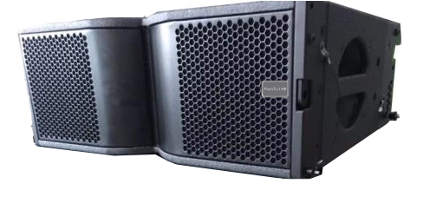

|  |  |
| --- | --- |
| Components | LF 2 x 8 (Neodymium magnet) / HF 1 x 3 (75mm Neodymium magnet) |
| Connectors | 2 x NEUTRIK NL4 |
| Frequency response | 65Hz-18KHz |
| Sensitivity (1W/1M) | 101 dB |
| Maximum sound pressure | 127 dB |
| Rated power | 550 Watts |
| Maximum power | 1100 Watts |
| Nominal impedance | 8Ω |
| Coverage | H 110°×V10° |
| Height x width x depth | 250 x 700 x 379mm |
| Weight | 23.5 Kg |

**Specification:**