**FT_DS-G10 E-L-V2.0.2.231219**

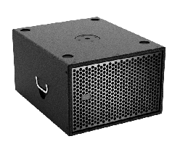

**Feature:**

1. Push-pull 6th order bandpass design

2. Compact cabinet, achieving a maximum peak sound pressure level output of 136dB SPL

3. Low frequency limit as low as 30Hz

4. EASE Focus gll data file has been created

|  |  |
| --- | --- |
| Frequency response range (-10dB) | 30Hz~150Hz |
| Maximum sound pressure level SPL | 136dB SPL peak |
| Coverage angle | horizontal (H) 360°, vertical (V) 180° |
| Unit structure | 2 x 14″ paper cone bass |
| Nominal impedance | 8Ω |
| Power (AES) | 1000W |
| Dimensions (W x H x D) | 448 x 490 x 550 mm / 17.6 x 19.3 x 21.7 in |
| Cabinet | Baltic birch plywood, super wear-resistant professional polyurea paint |
| Weight | 35 kg / 77 lbs |

**Specification:**