**FT_DS-G10 E-L-V2.0.2.231219**

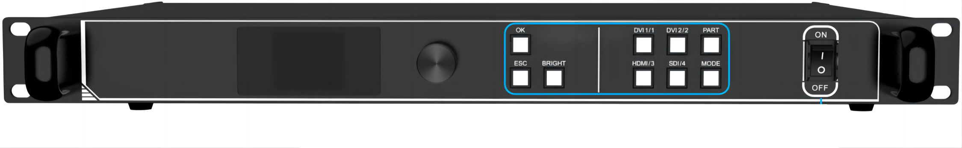

**Specification:**

· **Supports Multiple Digital Signal Interfaces**: 2 × DVI, 1 × HDMI, 1 × SDI

· **Maximum Input Resolution**: 1920 × 1200 @ 60Hz, supports arbitrary resolution settings

· **Maximum Load Capacity**: 3.9 million pixels, up to **8192 pixels wide** or **4096 pixels high**

· **Supports Arbitrary Video Source Switching and Scaling**

· **Supports Triple-Screen Display with Adjustable Position and Size**

· **Supports HDCP 1.4**

· **Dual USB 2.0 High-Speed Communication Ports**: For PC debugging and master controller cascading

· **Supports Brightness and Color Temperature Adjustment**; Also supports contrast, hue, and saturation adjustment

· **Supports Low-Brightness High-Gray Mode**

· **Compatible with FionTu’s Full-Series Receiving Cards, Multi-Function Cards, and Fiber Transceivers**