**FT_DS-G10 E-L-V2.0.2.231219**

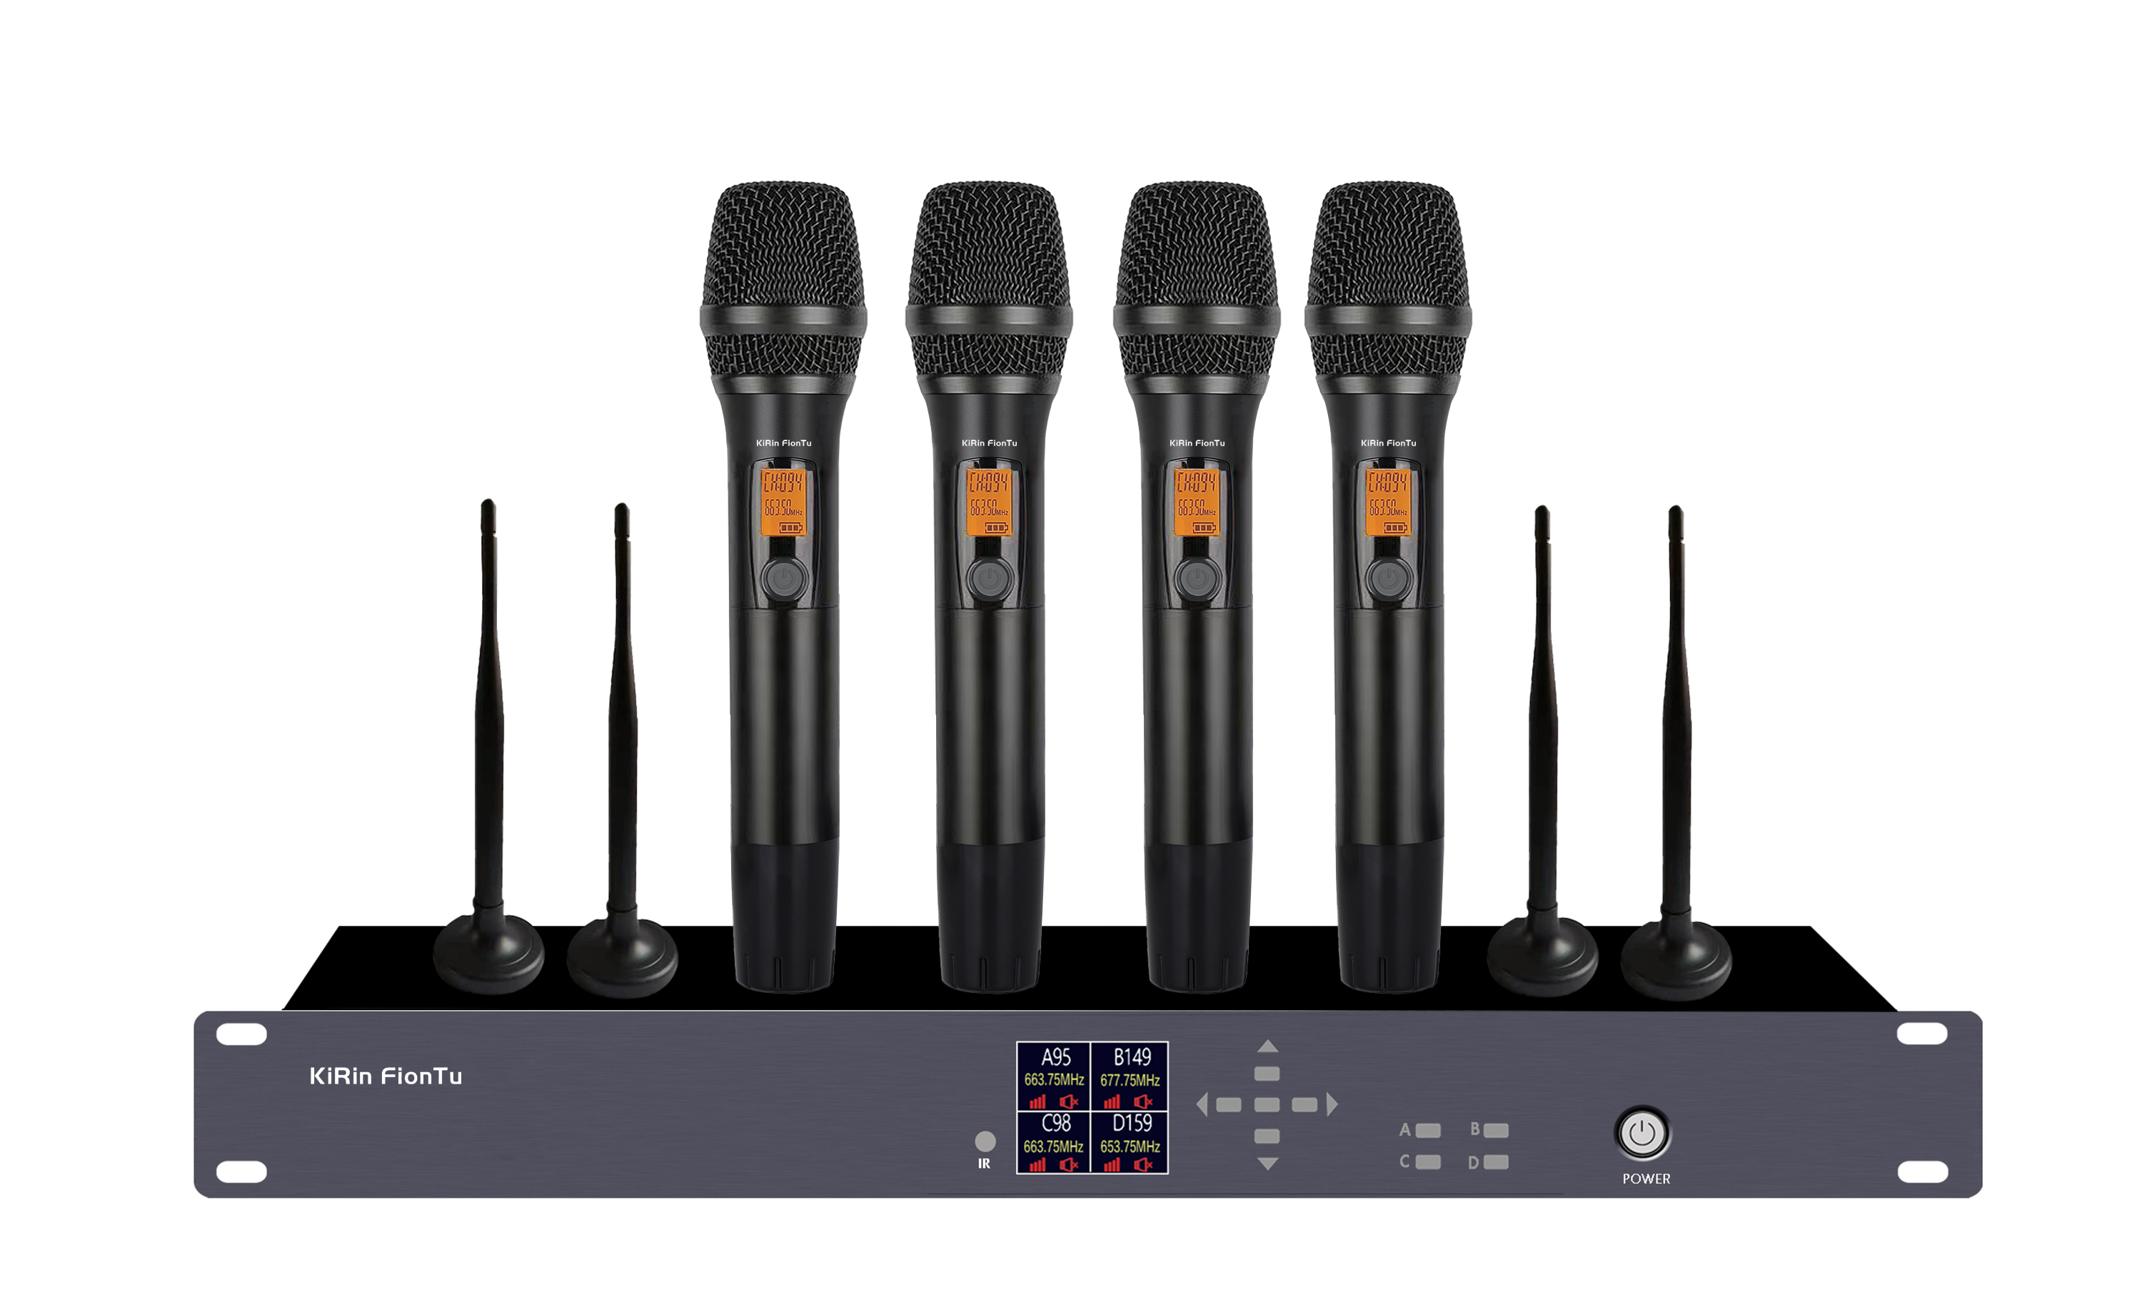

**Feature:**

**Specification:**

1. The receiver uses a 1.8-inch TFT color display screen, and the 4-channel channel number, frequency, power, volume, and audio level are clearly visible

2. The receiver has built-in howling suppression, which can be turned on or off as needed

3. The receiver has 4 built-in EQ modes, and the user mode can freely and flexibly adjust the 13-band EQ gain, which is suitable for use in more occasions

4. The receiver uses diversity reception technology, and the CPU automatically selects the optimal receiving unit to ensure that a stable signal is received to prevent frequency interruption

5. Dynamic random ID is used to eliminate cross-frequency, and the receiver only receives the last transmitter to be matched

6. The receiver presets multiple groups of frequencies to avoid interference, which effectively improves the installation efficiency of multiple sets used at the same time

|  |  |
| --- | --- |
| Frequency range | 640-690MHz |
| Modulation mode | broadband FM |
| Number of channels | 200 channels |
| Frequency stability | ±0.001% |
| Dynamic range | >100dB |
| Peak frequency deviation | ±45KHz |
| Frequency response | 50Hz-18KHz (±3dB) |
| Comprehensive signal-to-noise ratio | >105dB |
| Comprehensive distortion | <0.5% |
| Usage distance | 100 meters |
| Receiver technical indicators |  |
| Receiving mode | Diversity reception CPU automatically selects the strongest signal channel |
| Frequency matching mode | infrared |
| Oscillation mode | PLL phase-locked loop |
| Number of channels | 200 channels |
| Bandwidth | 50MHz |
| Sensitivity | -95dBm |
| Audio output | Hybrid: 0-600mV, Balanced: 0-600mV |
| Power supply | DC 12V 1A |
| Transmitter technical indicators |  |
| Transmitting power | 20mW |
| Maximum number of channels | 200 |
| Spurious suppression | -60dB |
| Harmonic suppression | >55dBc |
| Power supply voltage | 1.5V AA battery*2 |
| Usage time | 8 hours |